|  |
| --- |
| *CometPark* |
| **System Architecture Document** |
| **SE 6387 Advanced Software Engineering Project**  **R.Z. Wenkstern**    ***03/25/2014*** |

|  |
| --- |
| **Group B *002*** |
| Arunkumar Manickam |
| Hariprasad Natarajan |
| Prasanna Venkatesh Venkitasamy |
| Rekha Muthulakshmi Nachadalingam |

# 

# Revision History

|  |  |  |  |
| --- | --- | --- | --- |
| **Version** | **Date** | **Decription** | **Authors** |
| 1.0 | 03/06/2014 | Completed initial draft | Arunkumar, Hariprasad Prasanna, Rekha |
| 2.0 | 03/09/2014 | Updated Sequence and Architecture diagram | Arunkumar, Hariprasad Prasanna, Rekha |
| 3.0 | 03/18/2014 | Added Executable State charts | Arunkumar, Hariprasad Prasanna, Rekha |
| 4.0 | 03/25/2014 | Updated the State charts | Arunkumar, Hariprasad Prasanna, Rekha |

Contents

Revision History 2

List of Figures 1

1. Subsystems Sequence Diagrams 2

1.1 Update Parking Spot Status 2

1.2 Find Vacant Parking Spot 3

1.3 Login 4

1.4 Manage Parking Spot 5

1.5 Update System Configuration 6

2. System Architecture with Operations 7

3. Statecharts 8

3.1 Statechart for the entire CometPark System 8

3.1.1 System State: OFF 8

3.1.2 System State: Running 8

3.1.3 System State: Vehicle Arrives 9

3.1.4 System State: Vehicle Leaves 10

3.1.5 System State: Web Application Receives a User Request 11

3.2 Statechart for each component of the system 11

3.2.1 Sensor 11

3.2.2 Controller 12

3.2.3 Web Application 13

3.2.4 Server 15

Appendix B: References 17

# List of Figures

Figure 1 Update Parking Spot Status 2

Figure 2 Find Vacant Parking Spot 3

Figure 3 Login 4

Figure 4 Manage Parking Spots 5

Figure 5 Update System Configuration 6

Figure 6 System Architecture 7

Figure 7 System State: Off 8

Figure 8 System State: Running 8

Figure 9 Vehicle Arrives-Controller Transmitting 9

Figure 10 Vehicle Arrives-Server Updating 9

Figure 11 Vehicle Leaves-Controller Transmitting 10

Figure 12 Vehicle Leaves-Server Updating 10

Figure 13 System State: Web Application Receives a User Request 11

Figure 14 Sensing Vacancy 11

Figure 15 Sensing Occupancy 12

Figure 16 Controller Listening 12

Figure 17 Controller Transmitting 13

Figure 18 Web Application Idle 13

Figure 19 Web Application Processing 14

Figure 20 Web Application After Processing 14

Figure 21 Server Ready State 15

Figure 22 Server Processing 15

Figure 23 Server After Processing 16

# 1. Subsystems Sequence Diagrams

## 1.1 Update Parking Spot Status

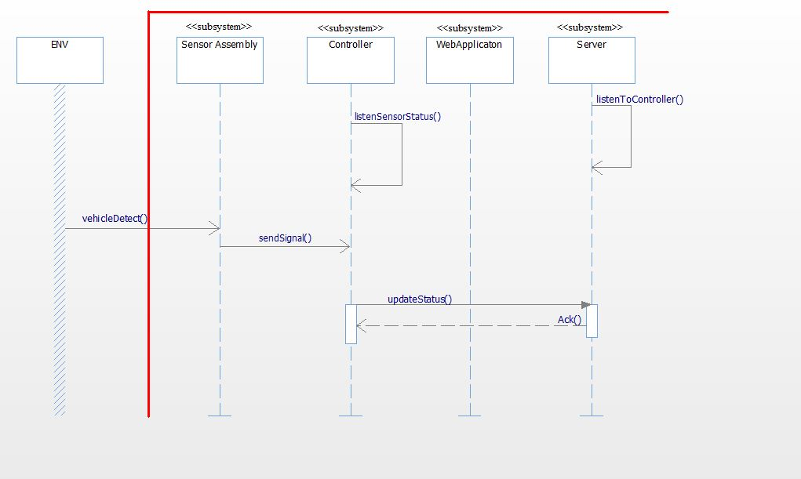

Figure 1 Update Parking Spot Status

## 1.2 Find Vacant Parking Spot

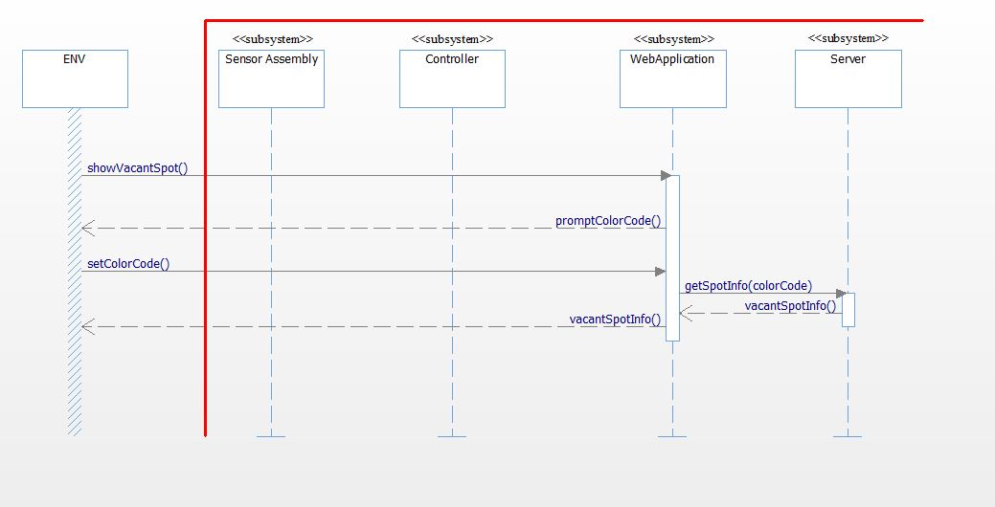

Figure 2 Find Vacant Parking Spot

## 1.3 Login

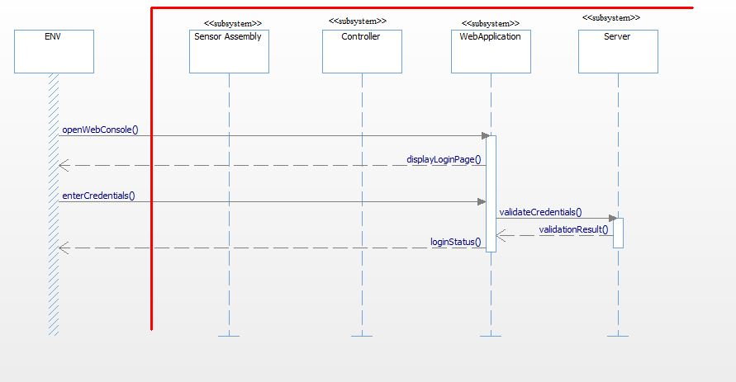

Figure 3 Login

## 1.4 Manage Parking Spot

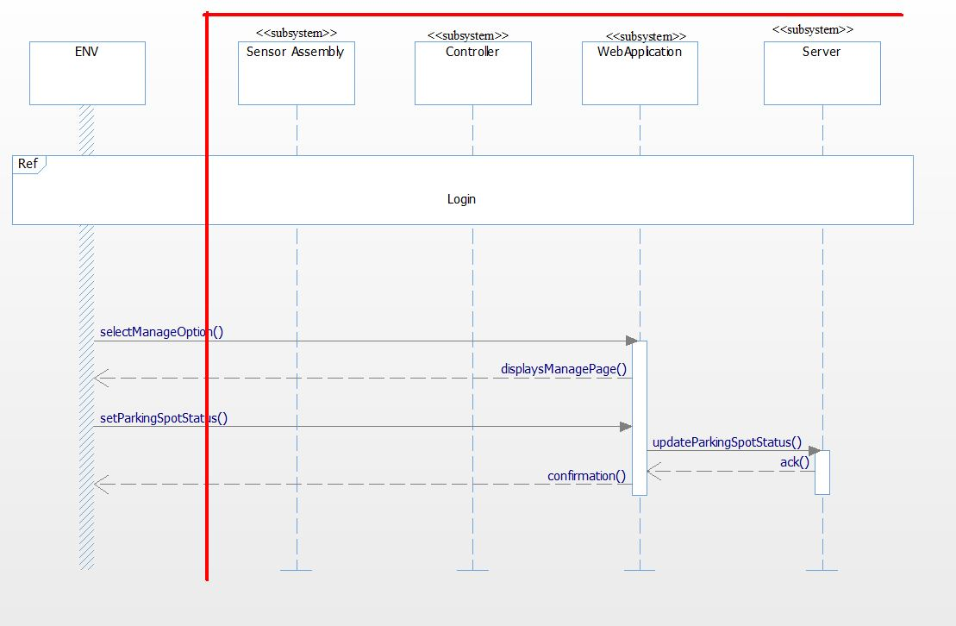

Figure 4 Manage Parking Spots

## 1.5 Update System Configuration

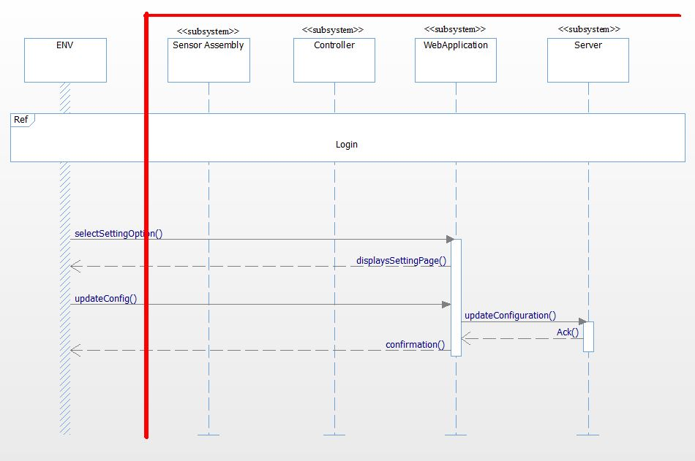

Figure 5 Update System Configuration

# 2. System Architecture with Operations

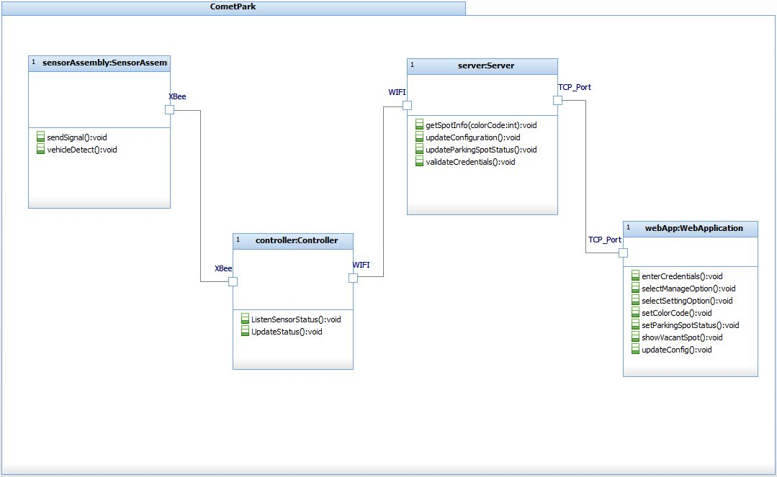

Figure 6 System Architecture

# 3. Statecharts

## 3.1 Statechart for the entire CometPark System

### 3.1.1 System State: OFF

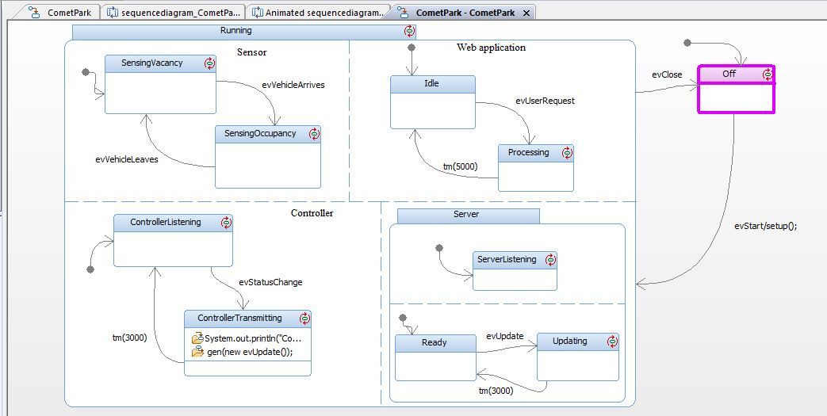

Figure System State: Off

### 3.1.2 System State: Running

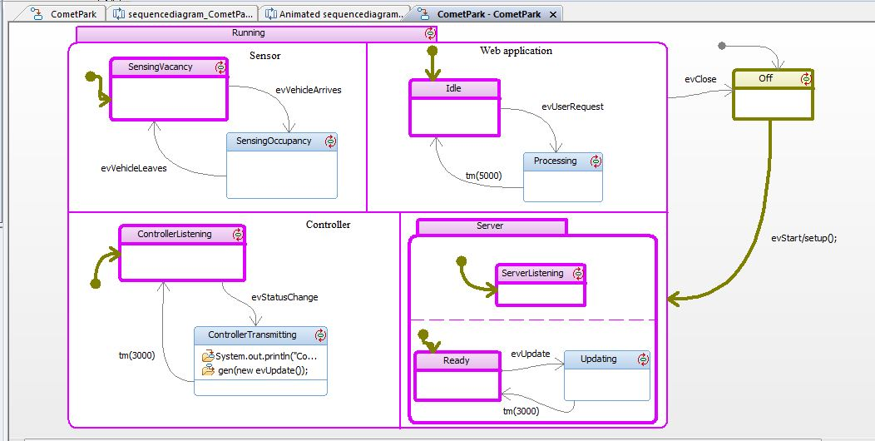

Figure System State: Running

### 3.1.3 System State: Vehicle Arrives

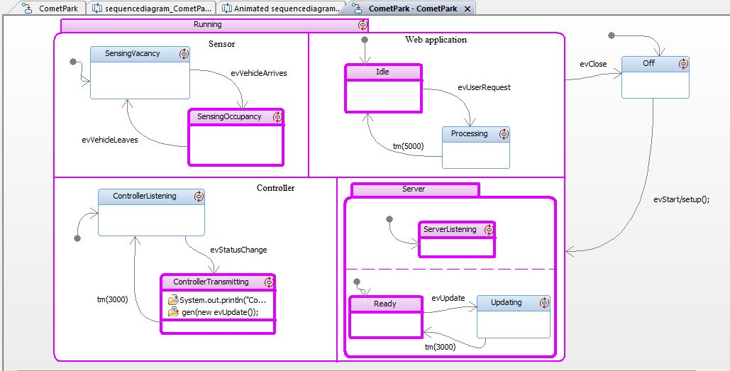

Figure Vehicle Arrives-Controller Transmitting

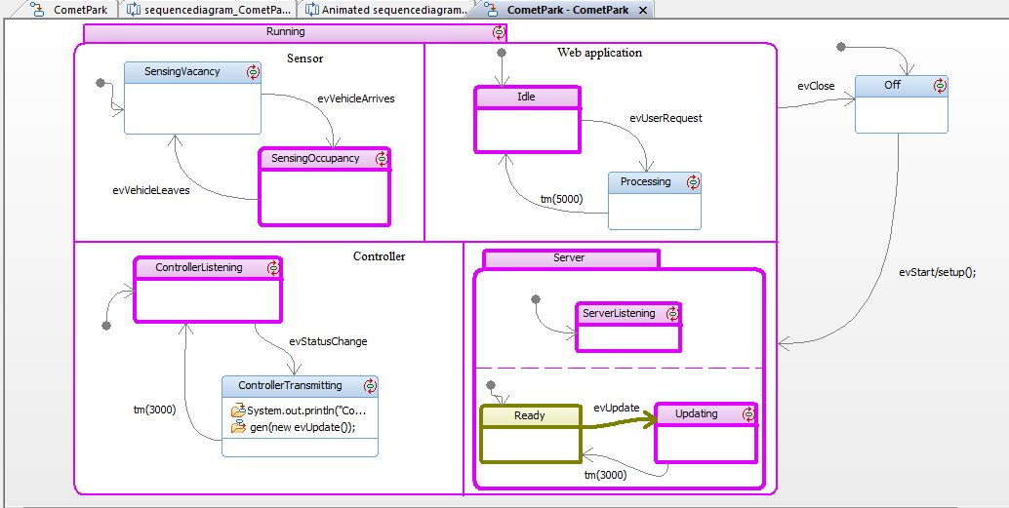

Figure Vehicle Arrives-Server Updating

### 3.1.4 System State: Vehicle Leaves

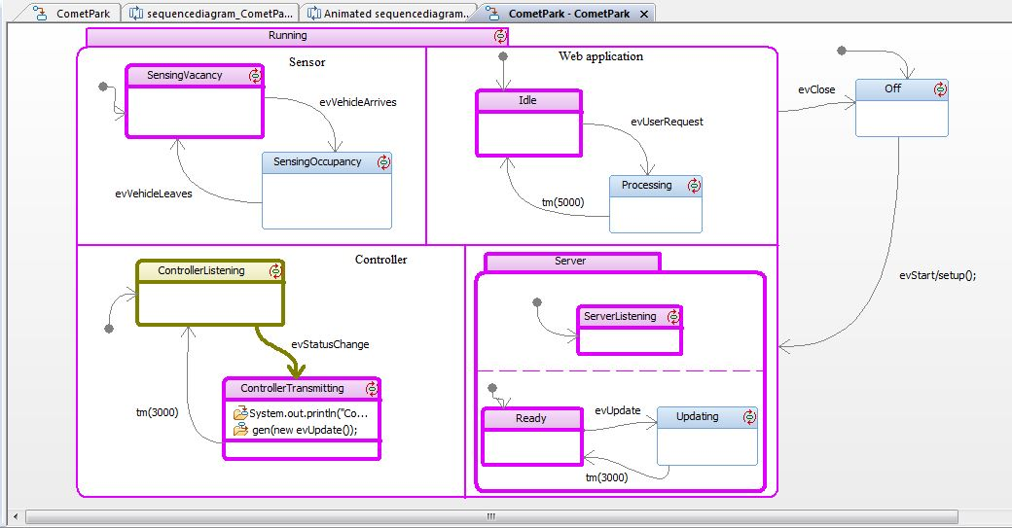

Figure Vehicle Leaves-Controller Transmitting

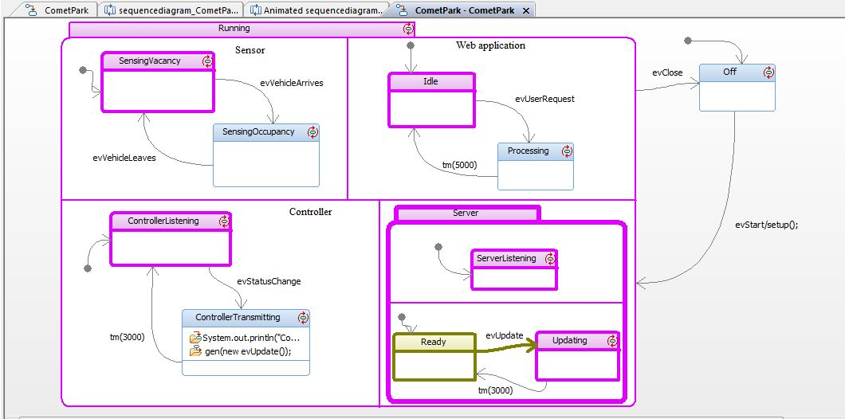

Figure Vehicle Leaves-Server Updating

### 3.1.5 System State: Web Application Receives a User Request

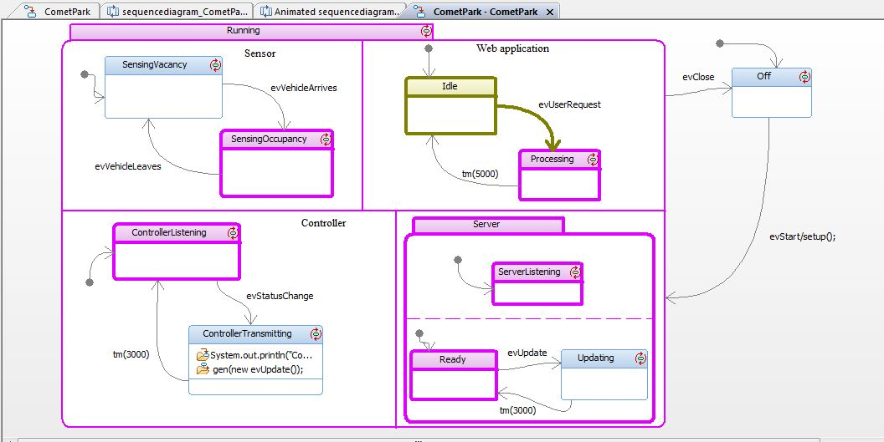

Figure System State: Web Application Receives a User Request

## 3.2 Statechart for each component of the system

### 3.2.1 Sensor

#### 3.2.1.1 Sensing Vacancy

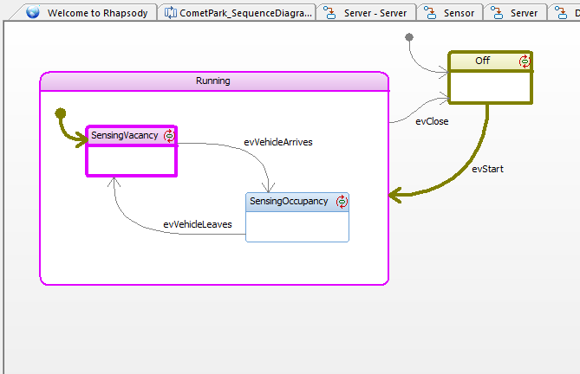

Figure Sensing Vacancy

#### 3.2.1.2 Sensing Occupancy

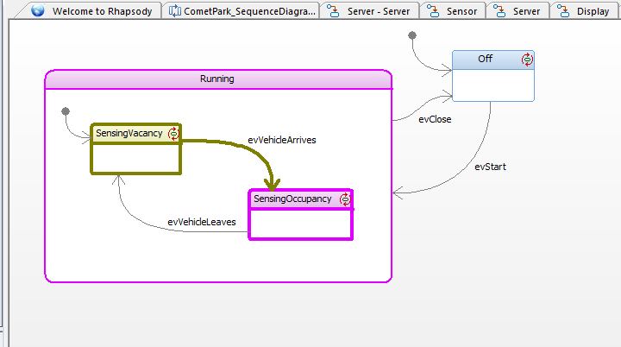

Figure Sensing Occupancy

### 3.2.2 Controller

#### 3.2.2.1 Controller Listening

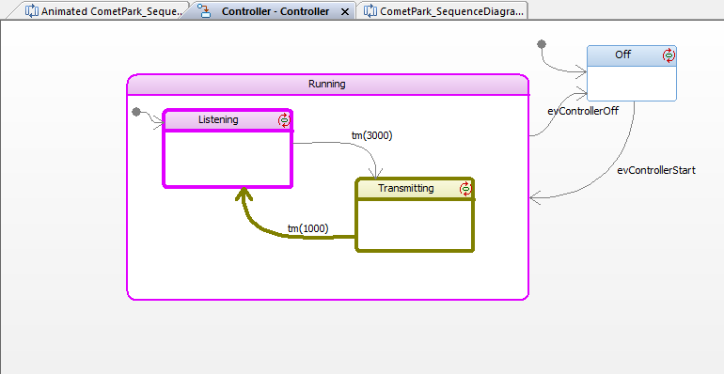

Figure Controller Listening

#### 3.2.2.2 Controller Transmitting

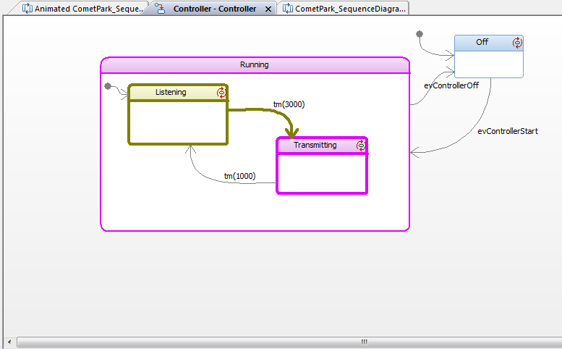

Figure Controller Transmitting

### 3.2.3 Web Application

#### 3.2.3.1 Web Application Idle

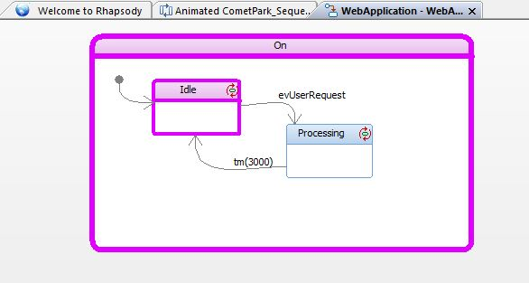

Figure Web Application Idle

#### 3.2.3.2 Web Application Processing

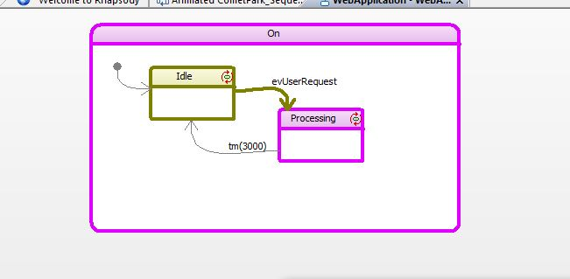

Figure Web Application Processing

#### 3.2.3.3 Web Application After Processing

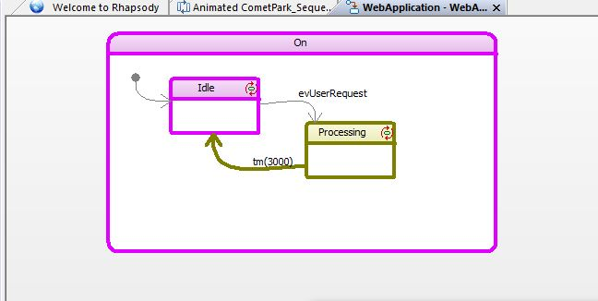

Figure Web Application After Processing

### 3.2.4 Server

#### 3.2.4.1 Server Ready State

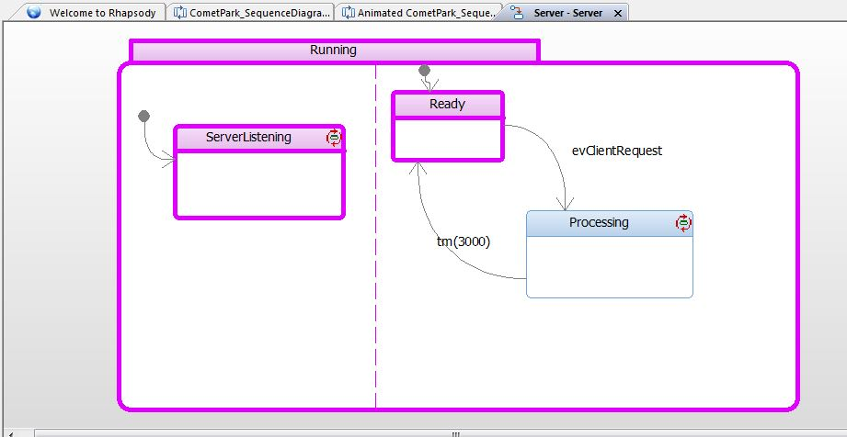

Figure Server Ready State

#### 3.2.4.2 Server Processing

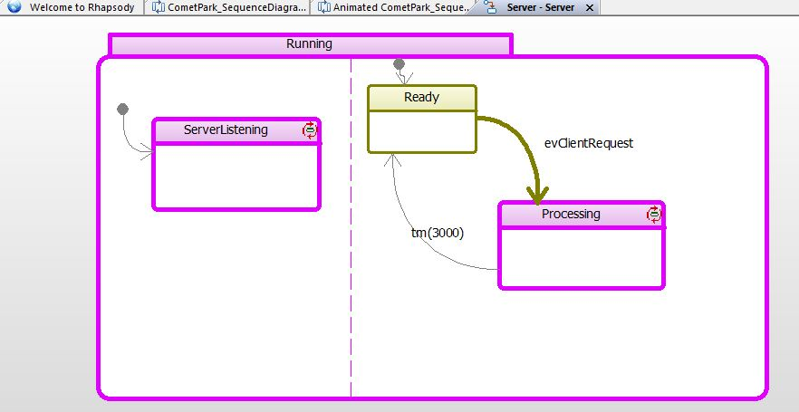

Figure Server Processing

#### 3.2.4.3 Server After Processing

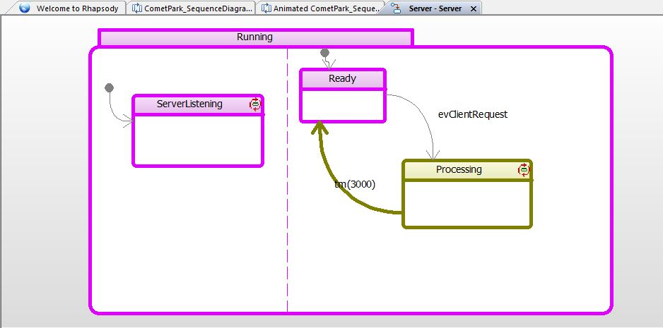

Figure Server After Processing

# Appendix B: References

[1] IBM Rational Rhapsody Tutorial <http://publib.boulder.ibm.com/infocenter/rsdp/v1r0m0/topic/com.ibm.help.download.rhapsody.doc/pdf75/tutorialcpp.pdf>

[2] Java Tutorial for Rational Rhapsody <https://publib.boulder.ibm.com/infocenter/rsdp/v1r0m0/topic/com.ibm.help.download.rhapsody.doc/pdf75/tutorialj.pdf>